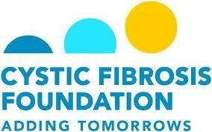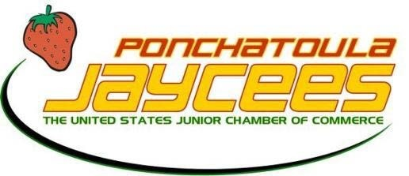
The 20th Annual
Harry McKneely-Milton Melancon Memorial

Jambalaya Cook-Off
Saturday, March 3rd, 2018
(Memorial Park, Ponchatoula, LA)

ENTRY FORM

Head Cook: _______________________________________________________ Name of Team: ____________________________________________________
Sponsor: _________________________________________________________
Cook’s Mailing Address: ______________________________________________
_________________________________________________________________
Cook’s Phone Number:_______________________________________________
Cook’s E-mail Address:_______________________________________________
*Which category will you be entering? (Please check all that apply)
JFA Non-JFA Pastalaya
Entry fee is $50.00 per category.
Please make checks payable to Ponchatoula Jaycees, P.O. Box 322, Ponchatoula, LA 70454.
Signature: ______________________________________ Date: __________________________________
For more information, please contact Brad Matherne at (985) 215-3639
or Megan Quigley at (985) 974-6849
Email ponchyjambalayacookoff@gmail.com
or www.facebook.com/Ponchyjambalayacookoff

